We are going to need a new VM with W7:
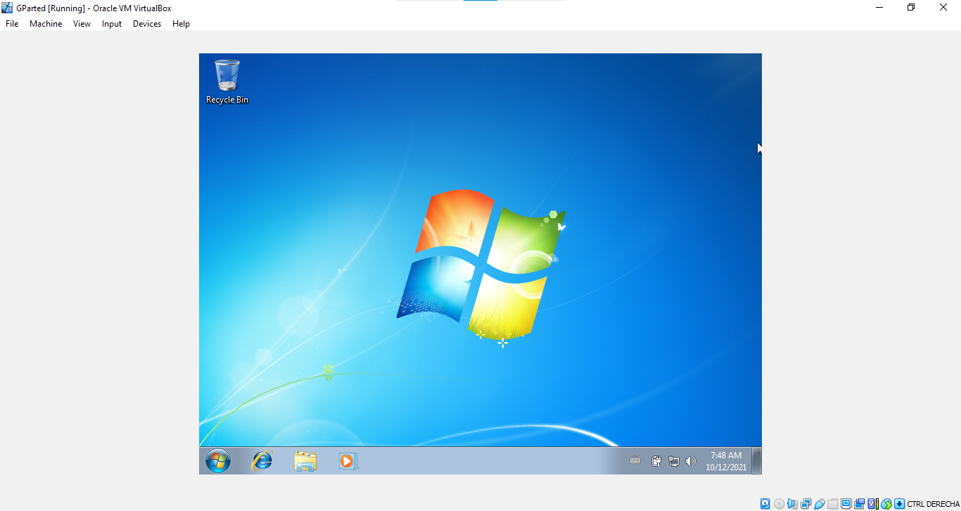

Exercise 1 :
First, we will create a new hard disk for the virtual machine, we have already created the new disk but we are going to show how to do it from the beginning:

We select the setting Storage:
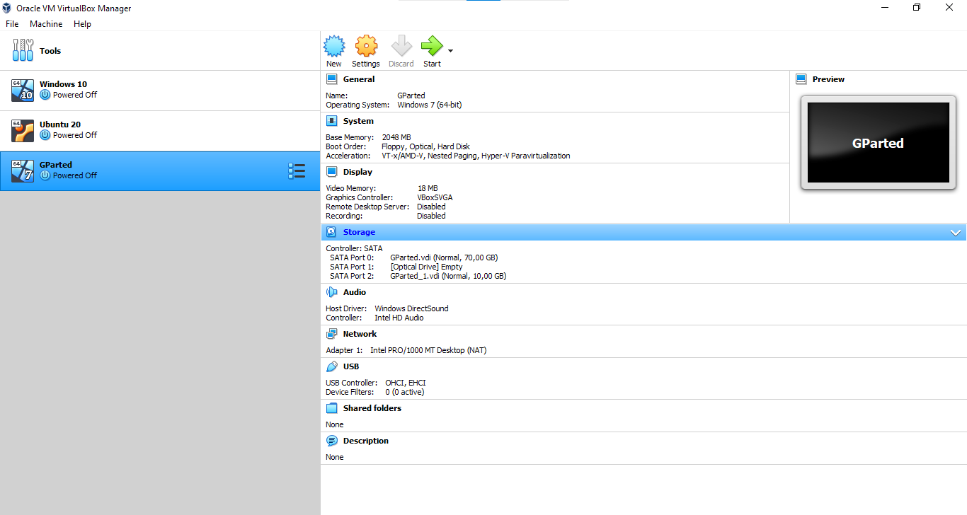

On the first option, Controller: SATA, you have to choose the option Add Hard Disk:
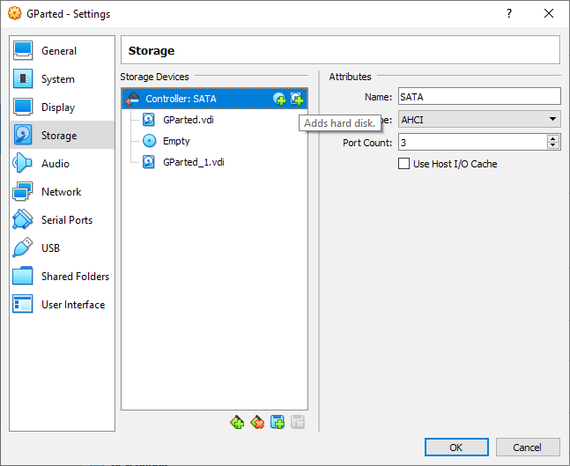

You will see the next screen on you machine, where you will select the option Create:
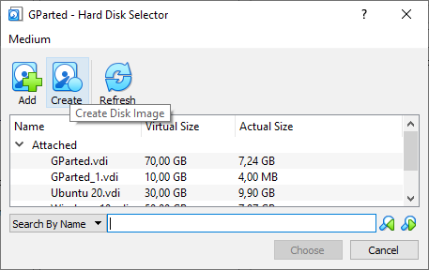

You choose the option VHD; then Dynamically allocated and then next:
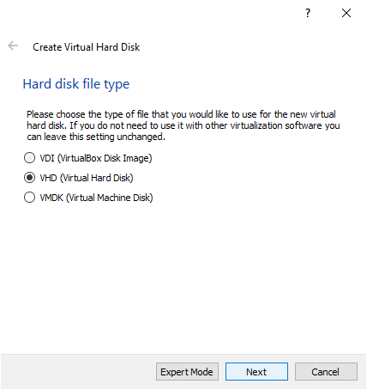
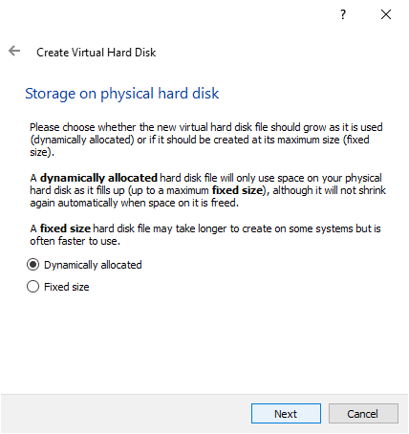

You select the size of your disk (10 GB) and finally Create:
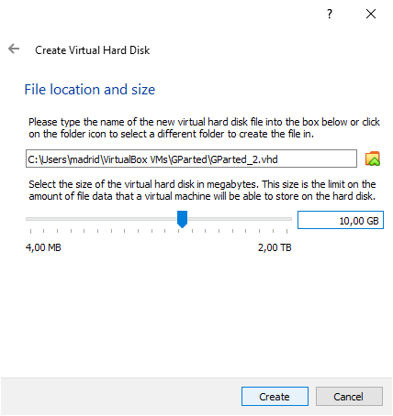

Now, we are ready to create the partitions required:
You must install the drb ISO File and then select Gparted from your desktop:
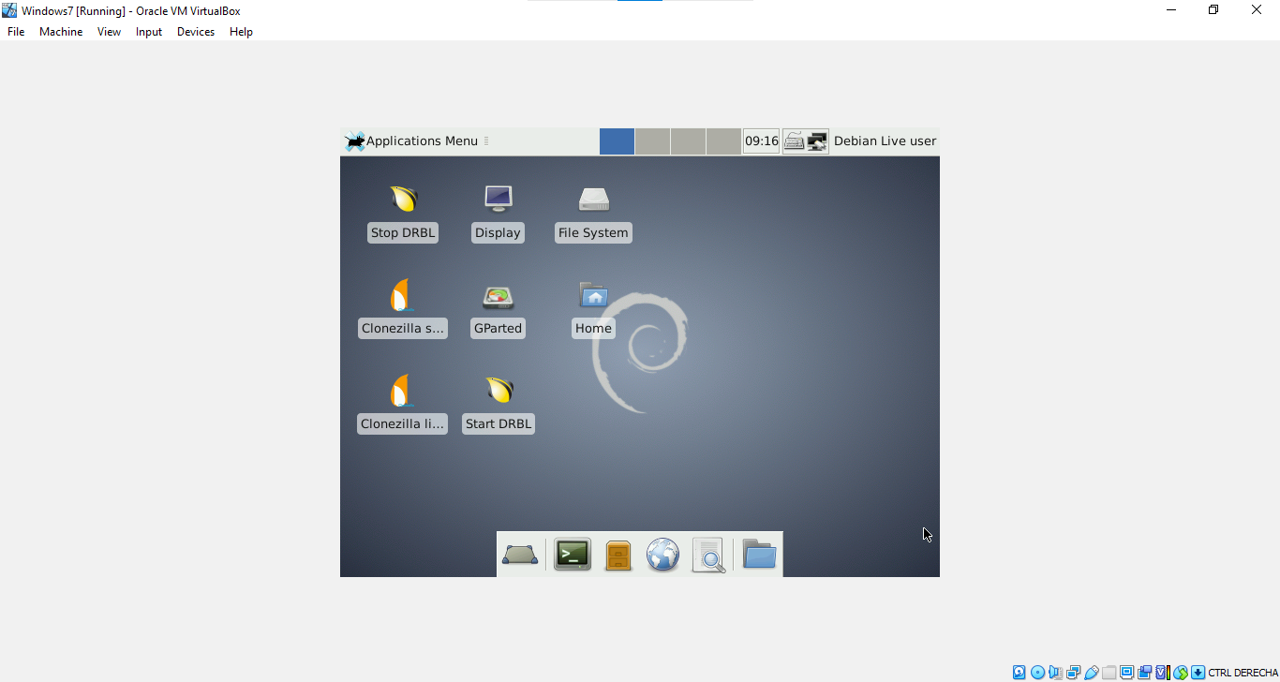

Then you choose the 10GB disk
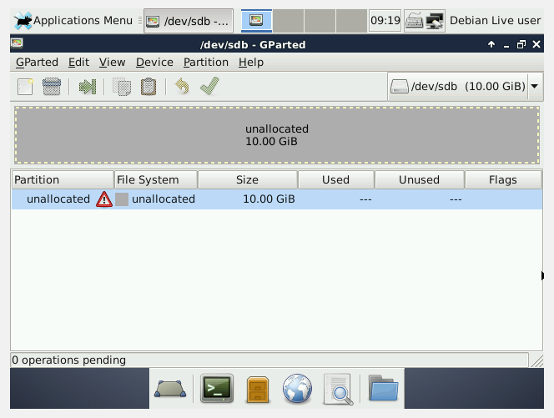

And then the option Device (inside the Gparted Window), and finally Create Partition Table, remember to select the MSDOS partition type:
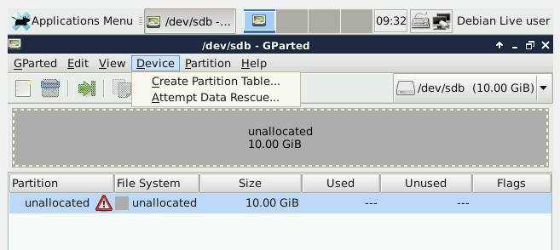
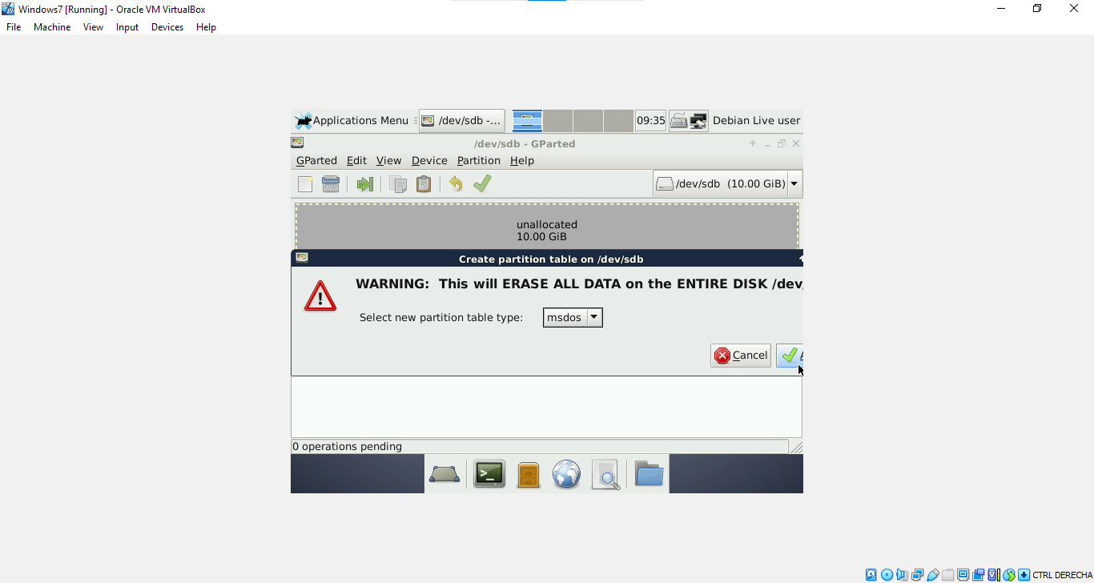

Then in the option Partition, select New:
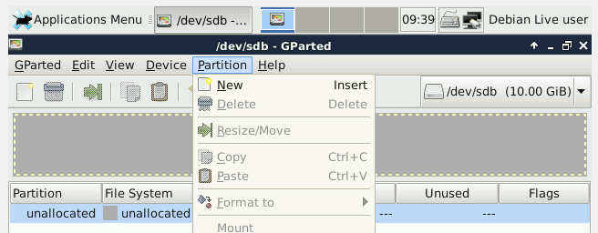

Now you will create a NTFS primary partition of 2GB called PNTFS:
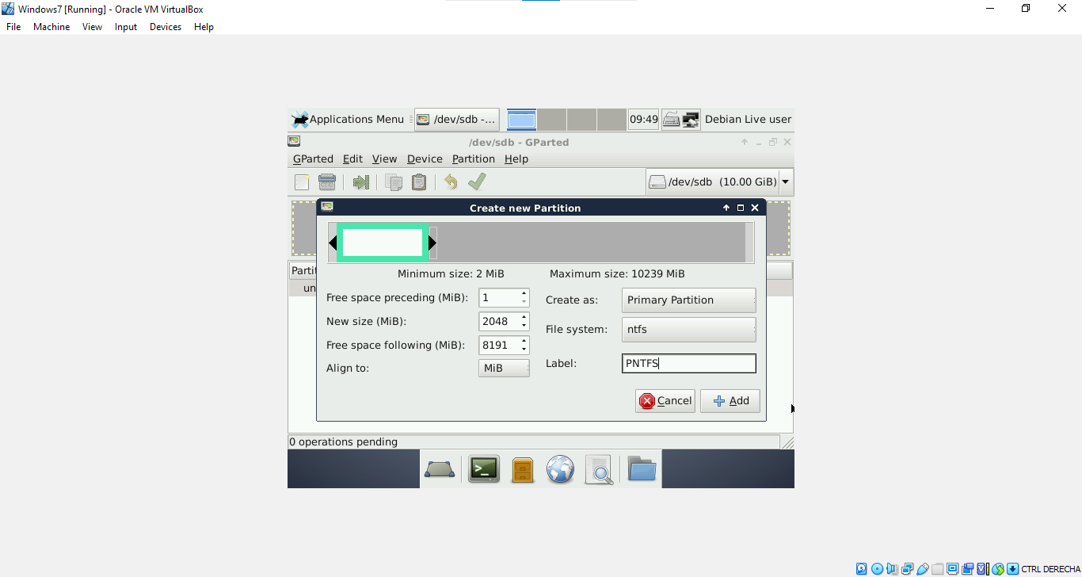
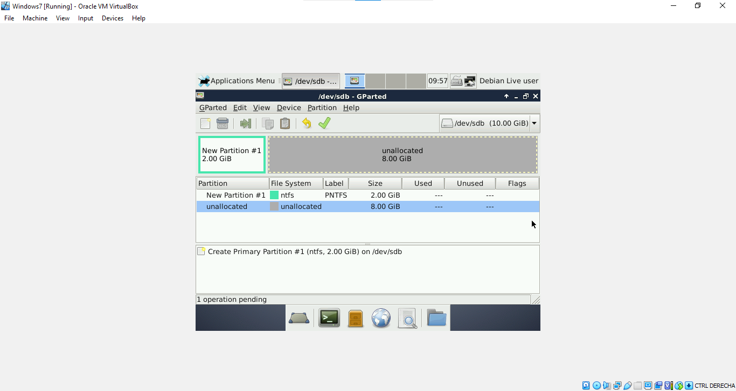

An EXT4 primary partition of 2GB called PEXT4:
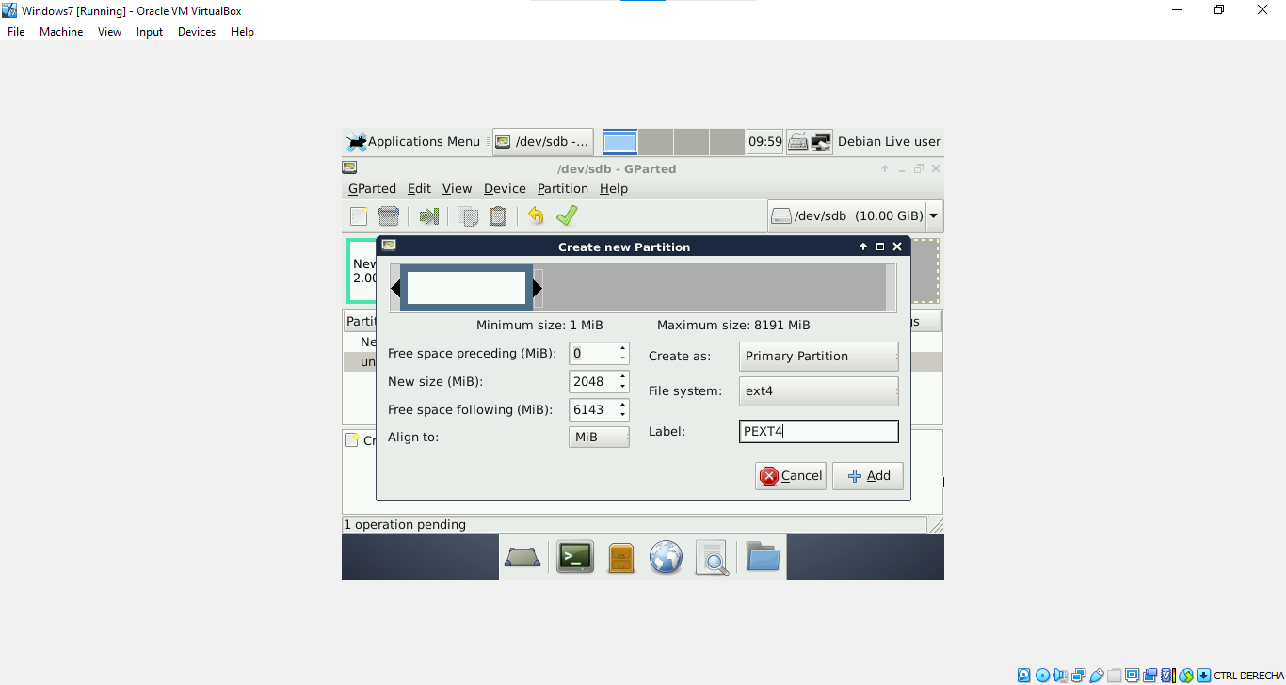

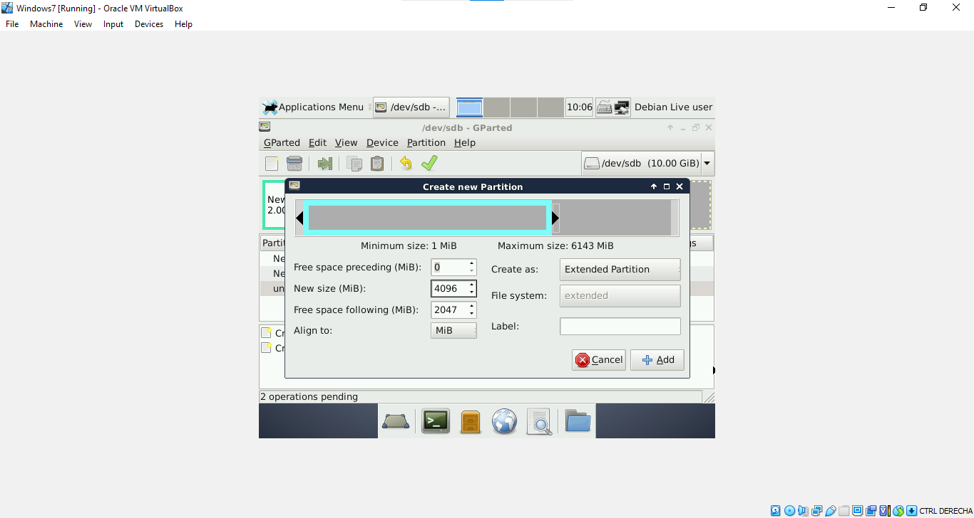
An extended partition of 4GB:

A logical partition of 2GB called PFAT32:
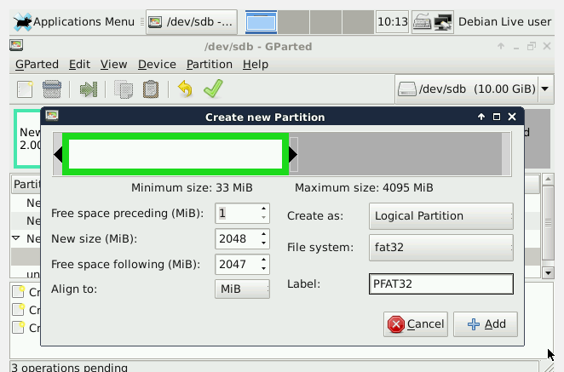

Your screen will be like this:
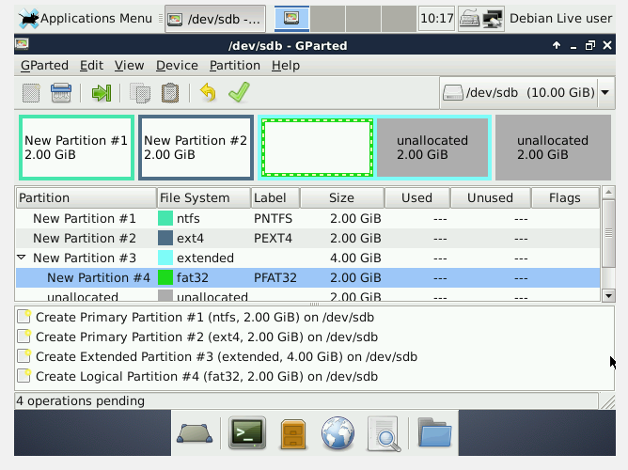

Now answer the following questions
1. Why is the file system not showed in the second partition?
2. If you had to create a new partition to store 2 GB data, where would you put the partition
in? In the extended partition.
Which file system should you use? I do not know, I will ask my teacher in class because I have follow the instructions given but I do not what am I doing or what the partitions are for, because in my VM I do not find the normal Windows screen, only Gparted.
Justify your answer.

